**Practical Exercise: Configuring a REST API**

Training Objective

Create a REST API with a simple sequence and deploy it in the Micro Integrator.

High Level Steps

* Create an Integration project.
* Configure a REST API.
* Add a Log mediator.
* Deploy and test your new configuration.

**Note:** In this lab, you will deploy the solution for testing. The concepts of deployment will

be covered later in the course.

Detailed Instructions

**Sending a Simple Message to a Service**

What you'll build

Let’s try a simple scenario where a patient makes an inquiry specifying the doctor's specialization (category) to retrieve a list of doctors that match the specialization. The required information is available in a  back-end microservice.

To implement this use case, you will create a REST API resource and other artifacts using WSO2 Integration Studio, and then deploy them in the embedded WSO2 Micro Integrator instance. The default API resource will be configured to receive the client request in place of the back-end service, thereby decoupling the client and the back-end service. The response message with the requested doctor details will be routed back to the client through the same API resource.

Concepts and artifacts used

* REST API
* HTTP Endpoint
* Call Mediator
* Respond Mediator

Let's get started!

Step 1: Set up the workspace

Download the relevant [WSO2 Integration Studio](https://wso2.com/api-management/tooling/) based on your operating system.

Step 2: Develop the integration artifacts

Follow the instructions given in this section to create and configure the required artifacts.

**Create an Integration project**

An Integration project is a maven multi module project, which will contain all the required modules for the integration solution.

1. Open **WSO2 Integration Studio**.
2. Click **New Integration Project** in the **Getting Started** tab as shown below.

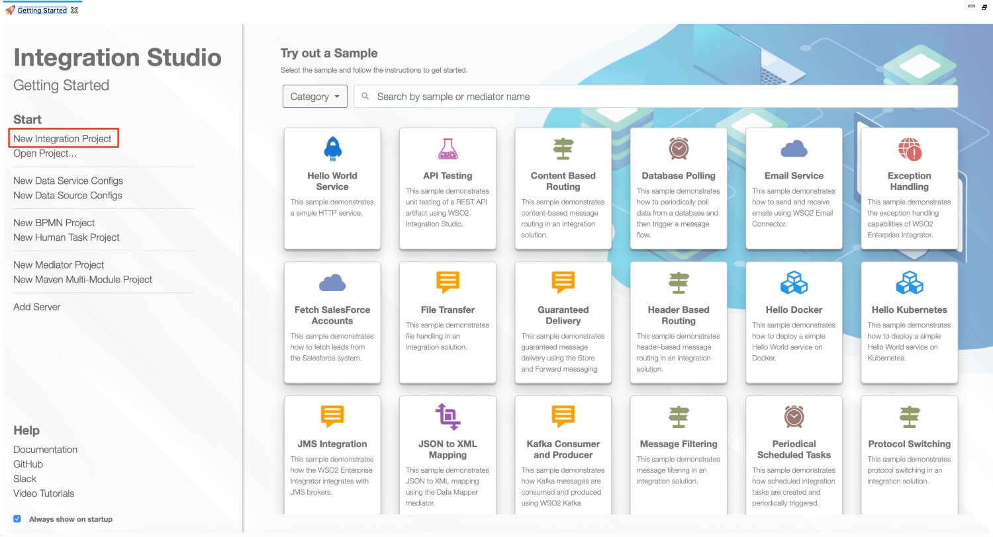

This will open the **New Integration Project** dialog box.

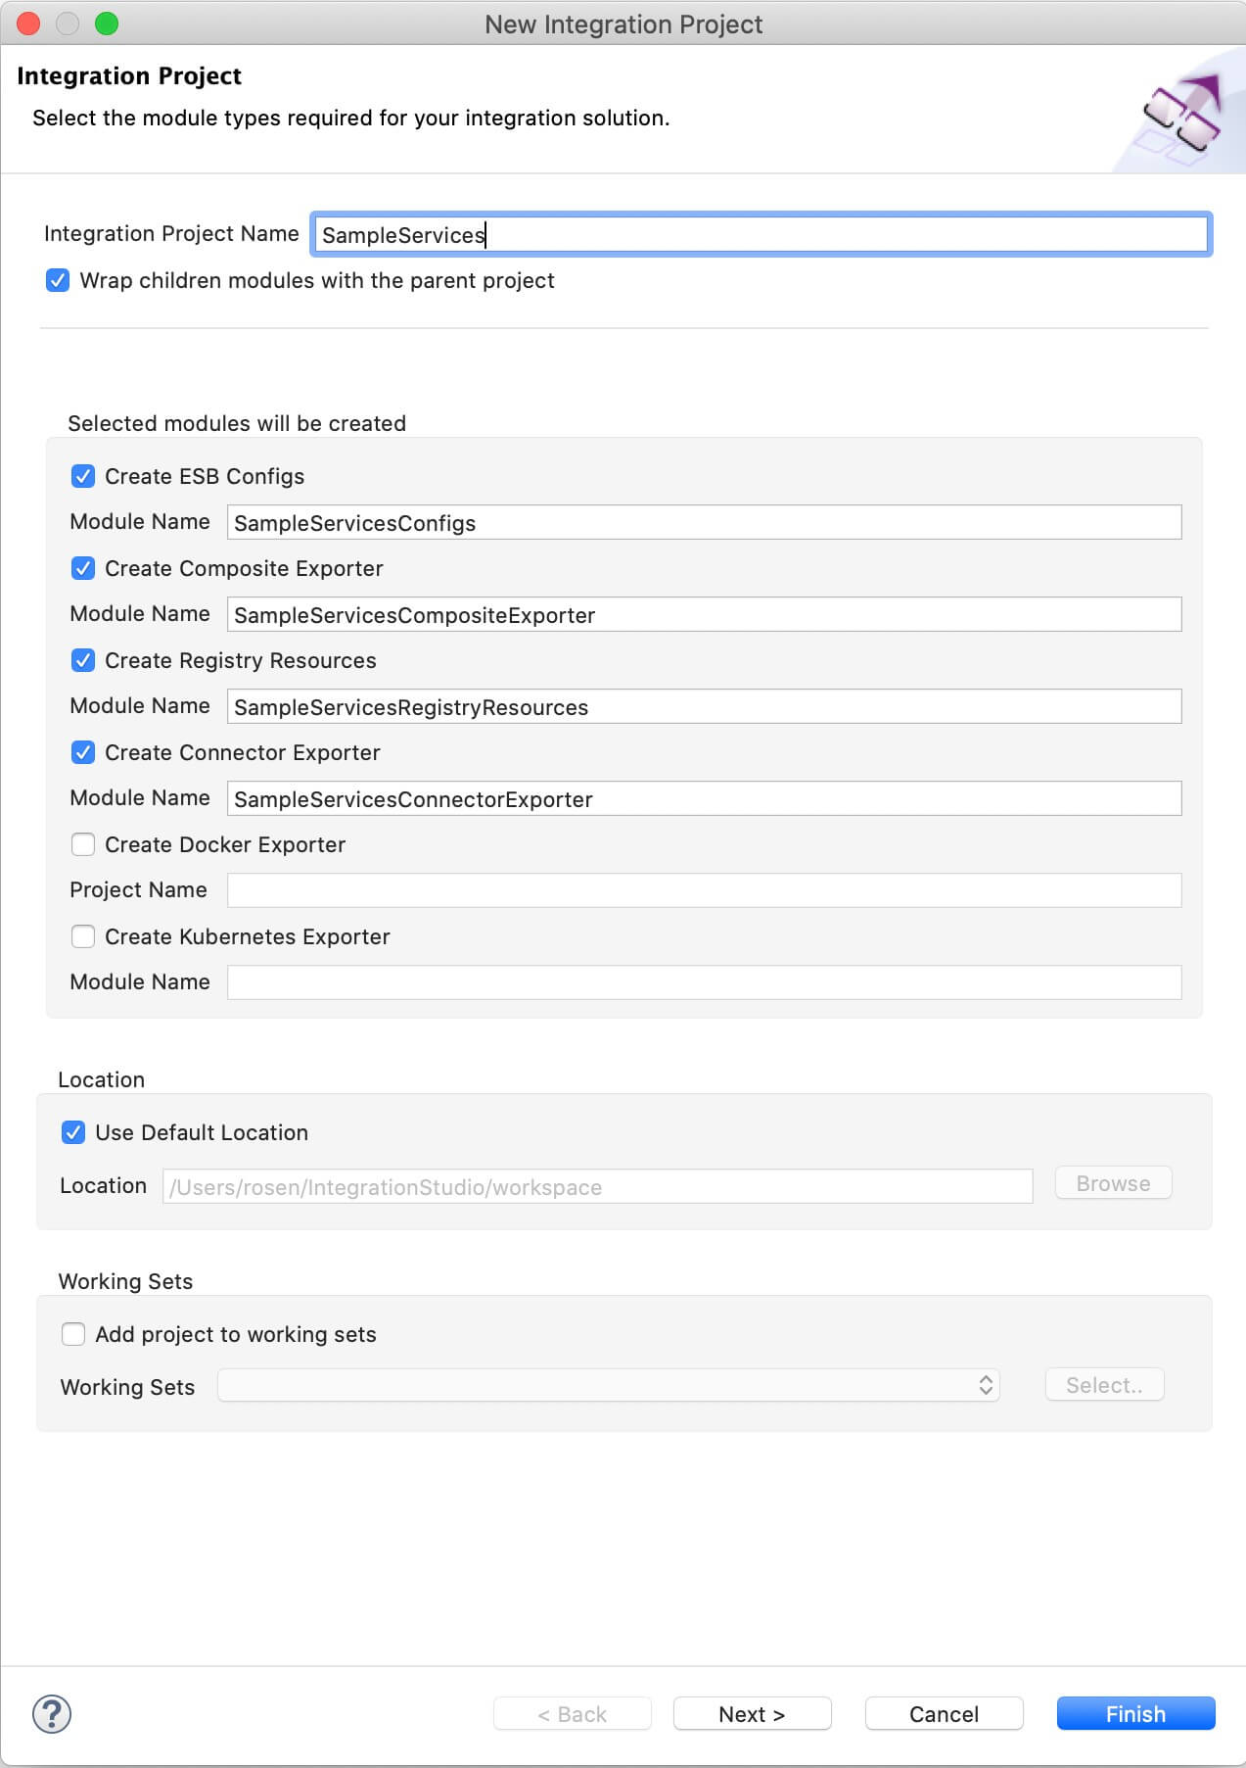

1. Enter SampleServices as the project name and select the following check boxes to create the required modules.
   * **Create ESB Configs**
   * **Create Composite Exporter**
2. Click **Finish**.

You will now see the projects listed in the **Project Explorer**.

**Create an Endpoint**

An Endpoint artifact is required for the purpose of exposing the URL that connects to the back-end service.

1. Right-click **SampleServicesConfigs** in the project explorer and click **New -> Endpoint**.
2. Ensure that **Create a New Endpoint** is selected and click **Next**.
3. Enter the information given below to create the new endpoint.

| Property | Value | Description |
| --- | --- | --- |
| Endpoint Name | QueryDoctorEP | The name of the endpoint. |
| Endpoint Type | HTTP Endpoint | Indicates that the back-end service is HTTP. |
| URI Template | http://localhost:9090/healthcare/{uri.var.category} | The template for the request URL expected by the back-end service. In this case, the variable 'category' that needs to be included in the request for querying doctors is represented as {uri.var.category} in the template. |
| Method | GET | Indicates that we are creating this endpoint for GET requests that are sent to the back-end service. |
| Save Endpoint in | SampleServicesConfigs | This is the **ESB Config** module where the artifact will be saved. |

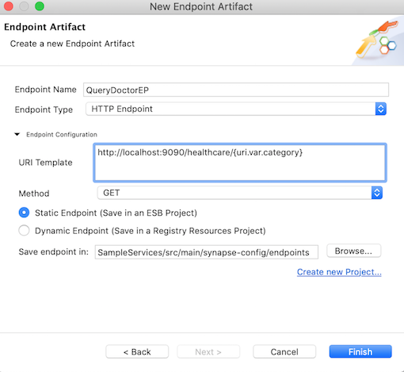

1. Click **Finish**.

The **QueryDoctorEP** endpoint is saved in the endpoints folder within the **ESB Config** module of the integration project.

**Create a REST API**

A REST API is required for receiving the client response and the REST resource within the API will define the mediation logic that will send requests to the Healthcare back-end service and retrieve the available doctor information.

1. In the Project Explorer, right-click **SampleServicesConfigs** and click **New -> REST API**.
2. Ensure **Create A New API Artifact** is selected and click **Next**.
3. Enter the details given below to create a new REST API.

|  |  |  |
| --- | --- | --- |
| Property | Value | Description |
| Name | HealthcareAPI | The name of the REST API. |
| Context | /healthcare | Here you are anchoring the API in the /healthcare context. This will become part of the name of the generated URL used by the client when sending requests to the Healthcare service. For example, setting the context to /healthcare means that the API will only handle HTTP requests where the URL path starts with http://host:port/healthcare. |
| Save location | SampleServicesConfigs | This is the **ESB Config** module where the artifact will be saved. |

|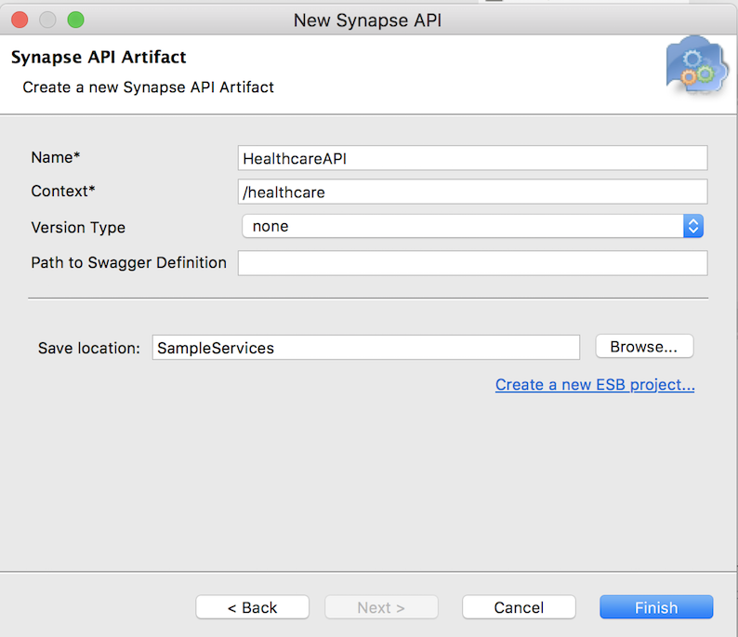

1. Click **Finish**.

**Define the mediation flow**

Once the API resource is created, the design view of the HealthcareAPI.xml file will appear as shown below

**Note**

* The top part of the canvas is the **In sequence**, which controls how incoming messages are mediated.
* The middle part of the canvas is the **Out sequence**, which controls how responses are handled. In this case, a **Send** mediator is already in place to send responses back to the requesting client.
* The bottom part of the canvas is the **Fault sequence**, which allows you to configure how to handle messages when an error occurs.

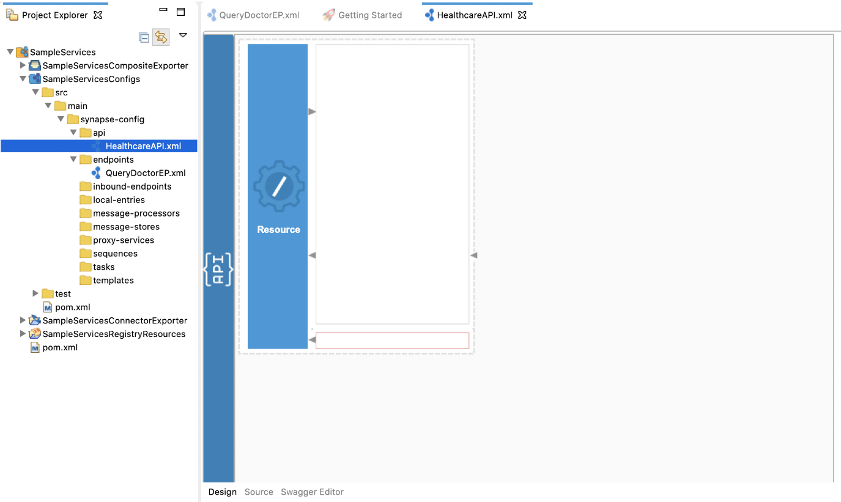

You can now start configuring the API resource.

1. Double-click the **Resource** icon on the left side of the canvas.  
   The properties for the API resource appear on the **Properties** tab at the bottom of the window. If they do not appear, you can right-click the **Resource** icon and click **Show Properties View**.
2. On the **Properties** tab, provide the following as **Basic** properties:

|  |  |
| --- | --- |
| Property | Description |
| Url Style | Click the respective **Value** field, click the down arrow, and then select **URI\_TEMPLATE** from the list. |
| URI-Template | Enter /querydoctor/{category}. This defines the request URL format. In this case, the full request URL format is http://host:port/querydoctor/{category} where {category} is a variable. |
| Methods | See that the **Get** check box is selected. This defines that the API resource only handles requests where the HTTP method is GET. |

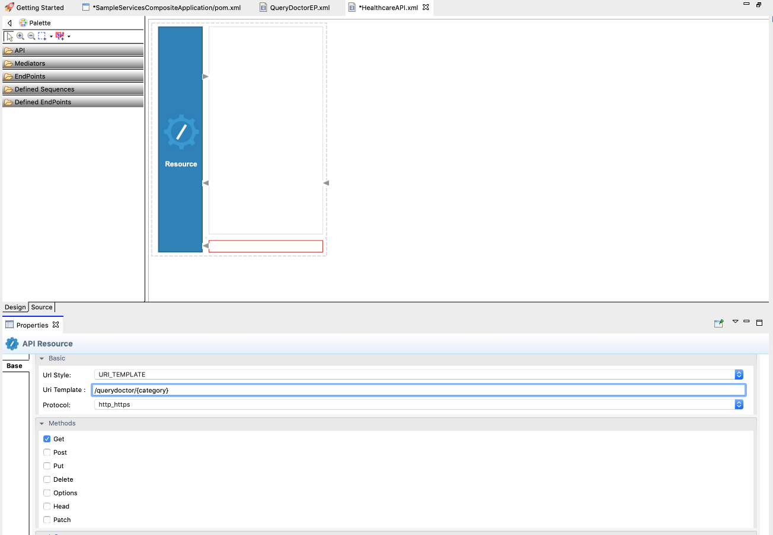

1. You can now configure the In sequence to handle requests from the client:
   1. From the **Mediators** palette, click and drag a **Log** mediator to the In sequence (the top of the canvas).

**Note**

The Log mediator logs messages when the request is received by the In sequence of the API resource. In this scenario, let's configure the Log mediator to display the following message: “Welcome to the HealthcareService”.

* 1. With the Log mediator selected, access the **Property** tab and fill in the information in the table below:

|  |  |  |
| --- | --- | --- |
| Field | Value | Description |
| Log Category | INFO | Indicates that the log contains an informational message. |
| Log Level | Custom | When Custom is selected, only specified properties will be logged by this mediator. |
| Log Separator | (blank) | Since there is only one property that is being logged, you do not require a separator. Therefore, leave this field blank. |
| Properties |  | To extract the stock symbol from the request and print a welcome message in the log, click the plus icon (https://apim.docs.wso2.com/en/4.1.0/assets/img/integrate/tutorials/common/plus-icon.png) in the **Properties** section, and then add the following values:   * + - **Name**: Log Property message     - **Type**: LITERAL (We select LITERAL because the required log message is a static value.)     - **Value/Expression** : "Welcome to HealthcareService"   https://apim.docs.wso2.com/en/4.1.0/assets/img/integrate/tutorials/119132413/119132423.png |
| Description | Request Log | The **Description** field provides the name that appears for the Log mediator icon in the design view. |

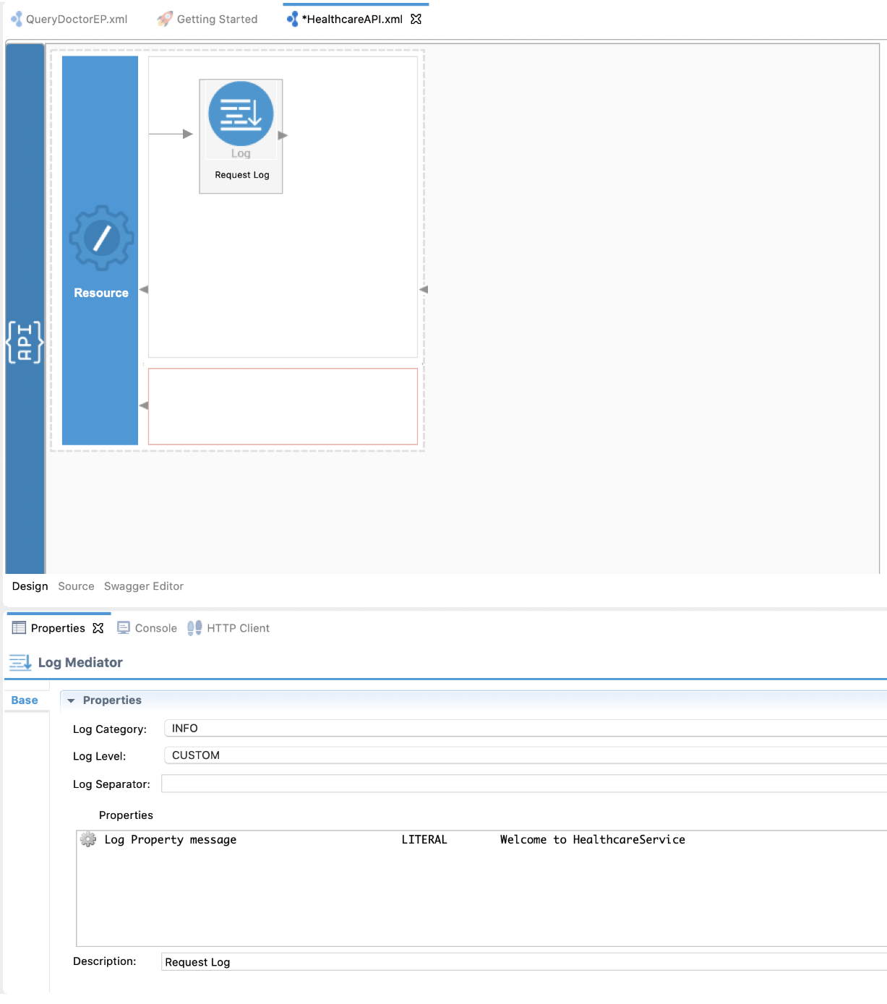

* 1. Click **OK** to save the Log mediator configuration.
  2. Configure a **Call** mediator to send the request message to the HealthcareService endpoint and receive the response message.
     + From the **Mediators** palette, click and drag a **Call** mediator to the In sequence adjoining the Log mediator you added above.
     + From the **Defined EndPoints** palette, click and drag the **QueryDoctorEP** endpoint, which we created, right next to the empty space of the **Call** mediator.

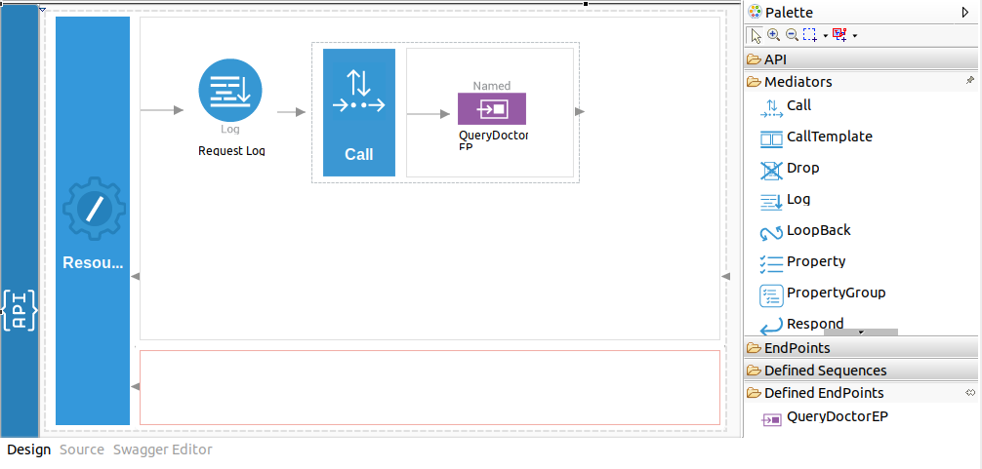

* 1. Add a **Respond** mediator at the end of the in sequence to send the response message from the healthcare service back to the client.

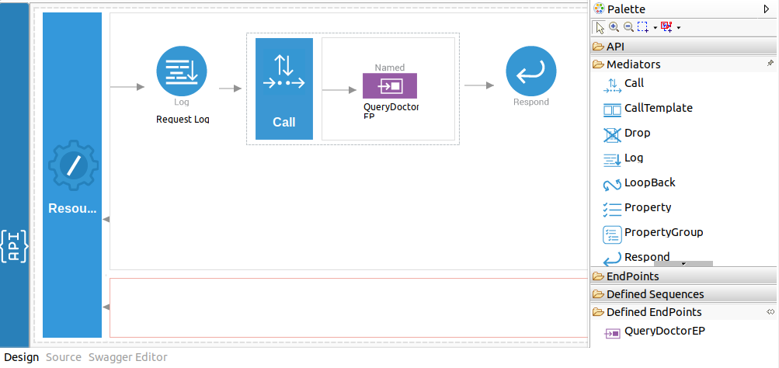

You have successfully created all the artifacts that are required for sending a request through the Micro Integrator to the back-end service.

Step 3: Package the artifacts

Package the artifacts in your composite exporter module to be able to deploy the artifacts in the server.

1. Open the pom.xml file of the **SampleServicesCompositeExporter** module.
2. Ensure that the following artifacts are selected in the POM file.
   * HealthcareAPI
   * QueryDoctorEP
3. Save the changes.

Step 4: Build and run the artifacts

To test the artifacts, deploy the [packaged artifacts](https://apim.docs.wso2.com/en/latest/tutorials/integration-tutorials/sending-a-simple-message-to-a-service/#step-3-package-the-artifacts) in the embedded Micro Integrator:

1. Right-click the composite exporter module and click **Export Project Artifacts and Run**.
2. In the dialog box that opens, confirm that the required artifacts from the composite exporter module are selected.
3. Click **Finish**.

The artifacts will be deployed in the embedded Micro Integrator and the server will start.

* See the startup log in the **Console** tab.
* See the URLs of the deployed services and APIs in the **Runtime Services** tab.

Step 5: Test the use case

Let's test the use case by sending a simple client request that invokes the service.

**Start the back-end service**

1. Download the JAR file of the back-end service from [here](https://github.com/wso2-docs/WSO2_EI/blob/master/Back-End-Service/Hospital-Service-JDK11-2.0.0.jar).
2. Open a terminal, navigate to the location where your saved the back-end service.
3. Execute the following command to start the service:

java -jar Hospital-Service-JDK11-2.0.0.jar

**Send the client request**

Let's send the request to the API. You can use the embedded **HTTP Client** of WSO2 Integration Studio as follows:

1. Open the Postman application. If you do not have the application, download it from here : [Postman](https://www.postman.com/downloads/)
2. Add the request information as given below and click the **Send** button.

|  |  |
| --- | --- |
| Method | GET |
| URL | http://localhost:8290/healthcare/querydoctor/surgery |

If you want to send the client request from your terminal:

1. Install and set up [cURL](https://curl.haxx.se/" \t "_blank) as your REST client.
2. Execute the following command.

curl -v http://localhost:8290/healthcare/querydoctor/surgery

**Analyze the response**

You will see the response message from the HealthcareService with a list of available doctors and the relevant details.

[

{"name":"thomas collins",

"hospital":"grand oak community hospital",

"category":"surgery",

"availability":"9.00 a.m - 11.00 a.m",

"fee":7000.0},

{"name":"anne clement",

"hospital":"clemency medical center",

"category":"surgery",

"availability":"8.00 a.m - 10.00 a.m",

"fee":12000.0},

{"name":"seth mears",

"hospital":"pine valley community hospital",

"category":"surgery",

"availability":"3.00 p.m - 5.00 p.m",

"fee":8000.0}

]

Now, check the **Console** tab of WSO2 Integration Studio and you will see the following message: INFO - LogMediator message = "Welcome to HealthcareService"

You have now created and deployed an API resource in the Micro Integrator, which receives requests, logs a message using the Log mediator, sends the request to a back-end service using the Send mediator, and returns a response to the requesting client.

**Best Practices**

* Create the main logic (i.e. REST API) in the main ESB Config module in the Integration project.